QUARTETTO
WERTHER

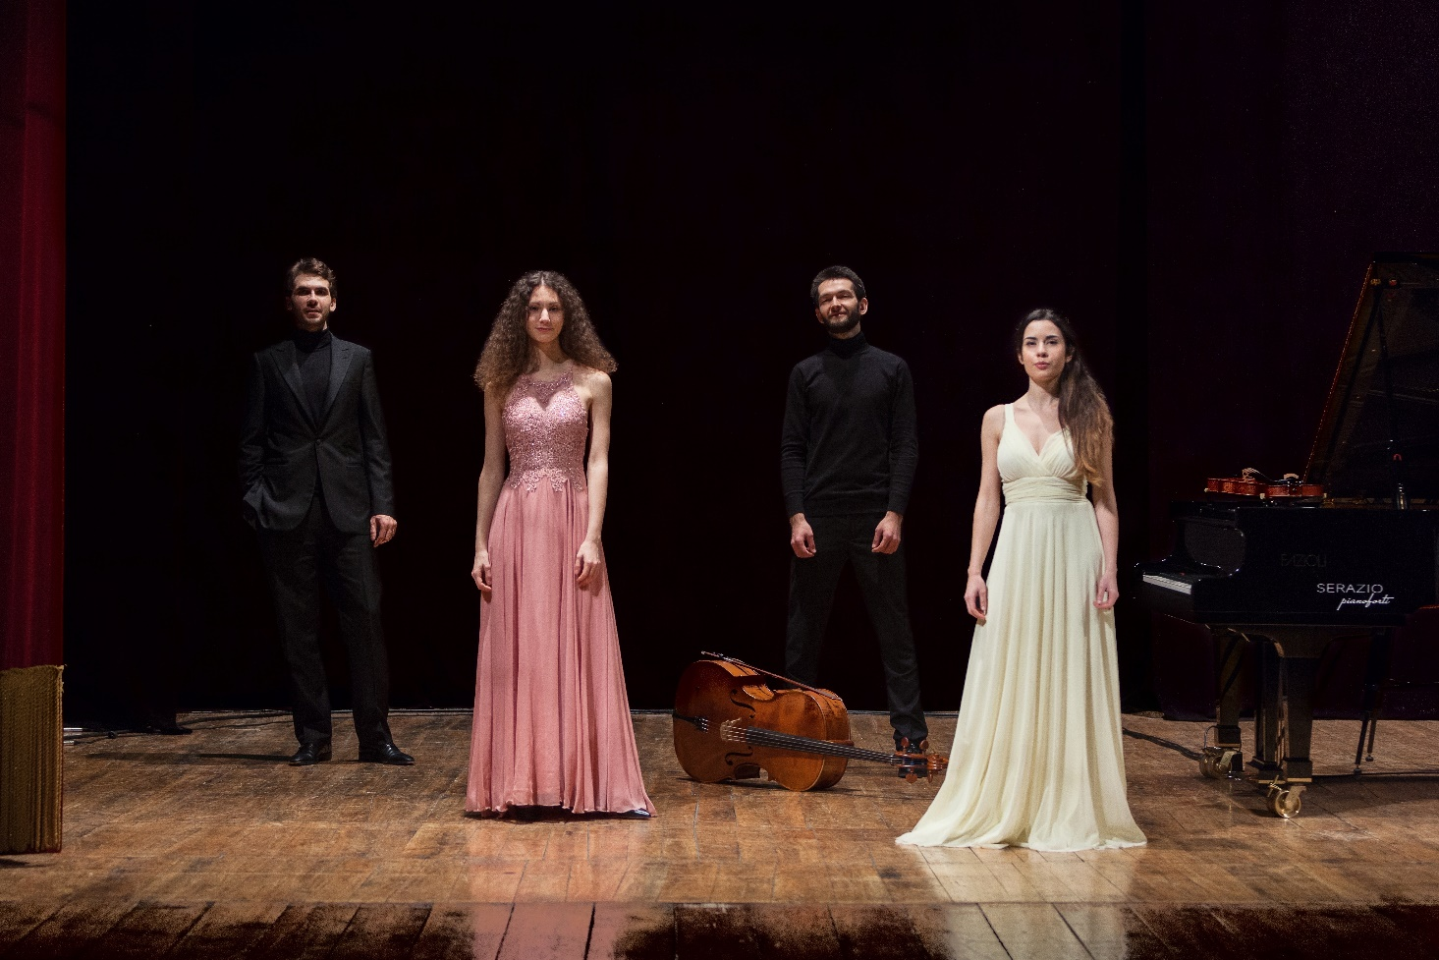

Quartetto Werther was awarded the Third Prize at the Concorso Internazionale di Musica da Camera “Trio di Trieste”, the Second Prize at the Concorso internazionale di Musica da Camera, Premio “L. Boccherini” and won the 2019 “Premio A. Burri” Prize, promoted by the 52nd Festival delle Nazioni.
The Quartett was established in Rome in 2016 and has recently been invited to participate at the 10th Osaka International Chamber Music Competition, part of the World Federation of International Music Competitions that will be held in Japan in 2021. Quartetto Werther was also awarded the XXXIX Franco Abbiati Prize (2020) by the National Association of Music Critics in Italy.
Endorsed by the Associazione Musica con le Ali, Quartetto Werther is making its name on the Italian chamber music scene. The ensemble has performed numerous concerts and participated in important Festivals and associations including Unione Musicale in Turin, Bologna Festival, Perugia Musica Classica, IUC, Società dei Concerti in Parma, Moscow International House of Music, Accademia Filarmonica Romana, Amici della Musica di Palermo, Fondazione Musicale “Santa Cecilia” in Portogruaro, Andermatt Music, Paganini Genova Festival Teatro Ristori in Verona, and Teatro “La Fenice” in Venice.
Quartetto Werther has perfected its preparation under the guidance of Trio di Parma and Pierpaolo Maurizzi attaing the Postgraduate in Chamber Music with Honors at the “A. Boito” Conservatory in Parma in 2018. The ensemble participated in the International Chamber Music Campus, an initiative of Jeunesse Musicale Deutschland at the Weikersheim Castle, perfecting its repertoire with the Cuarteto Casals and with Vivian and Donald Weilerstein.
Patrick Jüdt (ECMA) and Rainer Schmidt (Hagen Quartett) have also contributed profoundly to the artistic development of the ensemble. Quartetto Werther is a member of Le Dimore del Quartetto and is currently attending the chamber music course at the Accademia Nazionale di “Santa Cecilia” in Rome.
Besides the concert carreer, Quartetto Werther is also one of the chamber music teachers at the Avos Chamber Project in Rome.

DF Artists International Music Management
Member of the European Association of Artistic Agents and CMA
Vicolo Cadrega, 7
37121 VERONA Italy
mail: info@df-artists.com
cell phone: +39 392 9862385
Rif: Désirée Fusi

