MASSIMILIANO FERRATI

PIANO

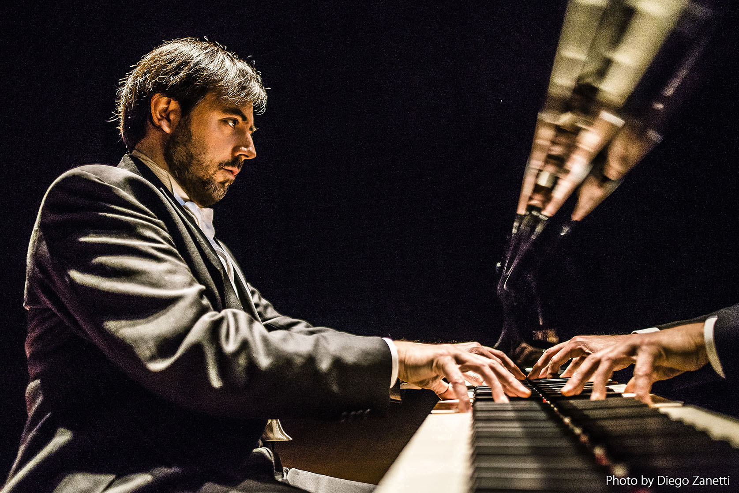

"There is no doubt that Ferrati is a superior pianist who has the spark of the artist."

Hanoch Ron, Yedioth Ahronot

“Massimiliano Ferrati demonstrated excellent technical skill together with the ability of emotional expression able to move the listener and the ability to create original musical images”

Paul Badura-Skoda, Applausi

“Filled with fervour, he "speaks the language" of the composers with enthusiasm of ideas, phrasing, questions. In his interpretation of Mozart. the image evolves moment by moment in a range of effective answers. In Chopin his highly refined sound turns to magic, the breath being held momentarily, the vigour, the exaltation. His Chopin is authoritative.”

Franca Cello, Corriere della Sera

"Ferrati’s sound was arrestingly distinctive: rich, focused and consistent. He is a superb player."

Michael Dungan, Evening Herald

"The Italian, Massimiliano Ferrati, is a bright, glowing expressionist. In Mozart he produced pearls; in Chopin he was spiritual; he sang; he was romantic, highly polished. And in Mussorgskij ("Pictures"), he blew up the auditorium. I mages of an erupting volcano. He was great, immense, original, compelling."

Ora Binur, Ma 'ariv (Israel

**MASSIMILIANO FERRATI** is one of the most impressive Italian musicians of his generation, renowned for his extraordinary musicality, tecnical strengh and charismatic performances.

Grand Pirx Winner at “Rina Sala Gallo International Piano Competition” in Monza and Bronze Medal at “Arthur Rubinstein Piano Master Competition” in Tel Aviv, Mr. Ferrati obtained prizes also at “UNISA International Piano Competition” in Pretoria (special prize for the "best performance of the Russian piece": Musorgskij's Pictures at an Exhibition), at the "Esther Honens International Piano Competition" in Calgary, at the “Dublin International Piano Competition”, at the “Ferruccio Busoni International Piano Competition” in Bolzano (where the jury awarded him also the special prize for Busoni works), at the "Alessandro Casagrande International Piano Competition” in Terni (where the jury awarded him also the special prize for Casagrande works).

He has given several recitals both in Italy and abroad, among them: Milan ("G. Verdi" Hall of the Conservatory on the occasion of the celebration of Nikita Magaloff), Padua ("Hall of Giants"), Turin (RAI Auditorium), Paris (Salle Cortot), Venice (Gran Teatro "La Fenice"), Florence (Palazzo Strozzi), Warsaw (State Philharmonia and Lazienki Palace), Hamburg (Musik-Halle), Naples (Teatro delle Palme and Teatro San Carlo), Salzburg (Wiener-Saal), Klagenfurt (Stadttheater), Munich (Kaulbach Villa), Calgary (Jack Singer Concert Hall), Dublin (National Concert Hall), New York (Mannes College of Music), Tel Aviv (Mann Auditorium and Tel Aviv Museum), London (Purcell Room), Leeds (Great Hall of the University), Pretoria (Old Mutual Hall) and Rome (Auditorium of the "S. Cecilia" Academy and Teatro Nazionale).

He has performed as soloist with many prestigious orchestras, such as: Calgary Philharmonic Orchestra, Gli Archi della Scala, Israel Philharmonic Orchestra, Moscow Symphony Orchestra, National Symphony Orchestra of Ireland, Orchestra di Padova e del Veneto, Orchestra "Haydn" di Bolzano e Trento, Orchestra Regionale del Lazio, Roma Sinfonietta, Orchestra da Camera Slesiana of Katowice with conductors like: Mario Brunello, Mendi Rodan, Anton Nanut, Robert Houlihan, Christoph Eberle, Bruno Aprea, Alberto Veronesi, Alexei Kornienko, Jan Wincenti Hawel and played with chamber groups such as: St. Lawrence String Quartet, Aviv String Quartet, Trio Rachmaninoff, Solisti dell'Orchestra d'Archi Italiana, TrioLogìa, Trio Veneto and artists as David Garrett, Sergey Ostrovsky, Fabio Paggioro, Stefano Furini, Danilo Rossi, Alberto Salomon, Luca De Muro, Simone Tieppo, Jacopo Francini, Davide Simoncini, Alessandro Carbonare.

His performances have been recorded and broadcasted by TVP (Telewizja Polska S. A.), CBC Radio & Television Canada, RTÉ (Radio Telefís Éireann), Bayerischer Rundfunk München, Radio Allegro Johannesburg, Israel Radio Voice of Music, BBC Radio, RAI Radio Televisione Italiana, Radio Ljubljana.

He has recorded the CD Mozart Piano Sonatas for Velut Luna, and for Brilliant Classics two monographic works on the italian composers Respighi and Martucci. Two more CDs with Prokofiev works will be released in 2019/2020.

Graduated with a first-class honours diploma at the "A.Buzzolla" Conservatory in Adria under the guidance of Mila Zamparo, he studied with very important teachers like the Russian pianist Konstantin Bogino, Paul Badura-Skoda and Sergio Perticaroli (at the Mozarteum in Salzburg and at the "S.Cecilia" Academy in Rome where he received the first-class honours diploma). He partecipated in Masterclasses with Fausto Zadra, Bruno Rigutto, Vladimir Ogarkov, Svetlana Bogino, Trio di Trieste (Dario De Rosa, Renato Zanettovich e Amedeo Baldovino), Piero Rattalino, Dina Joffe, Franco Rossi, Pier Narciso Masi.

He gives masterclasses regularly both in Italy and abroad (New York - International Keyboard Institute and Festival, Kiev - Ciaikovskij National Academy, Tokyo - Showa University) and takes part in Juries in International Piano Competitions such as Sidney Int. Piano Competition , A. Casagrande Int. Piano Competition Terni, Luciano Luciani Int. Piano Competition – Cosenza, IKIF New York.

He is currently Piano Professor at the Conservatory "Agostino Steffani" in Castelfranco Veneto - Treviso.

DF Artists

International Music Management

Vicolo Cadrega, 7

37121 VERONA Italy

mail: info@df-artists.com

cell phone: +39 392 9862385

Rif: Désirée Fusi