GOMALAN BRASS QUINTET
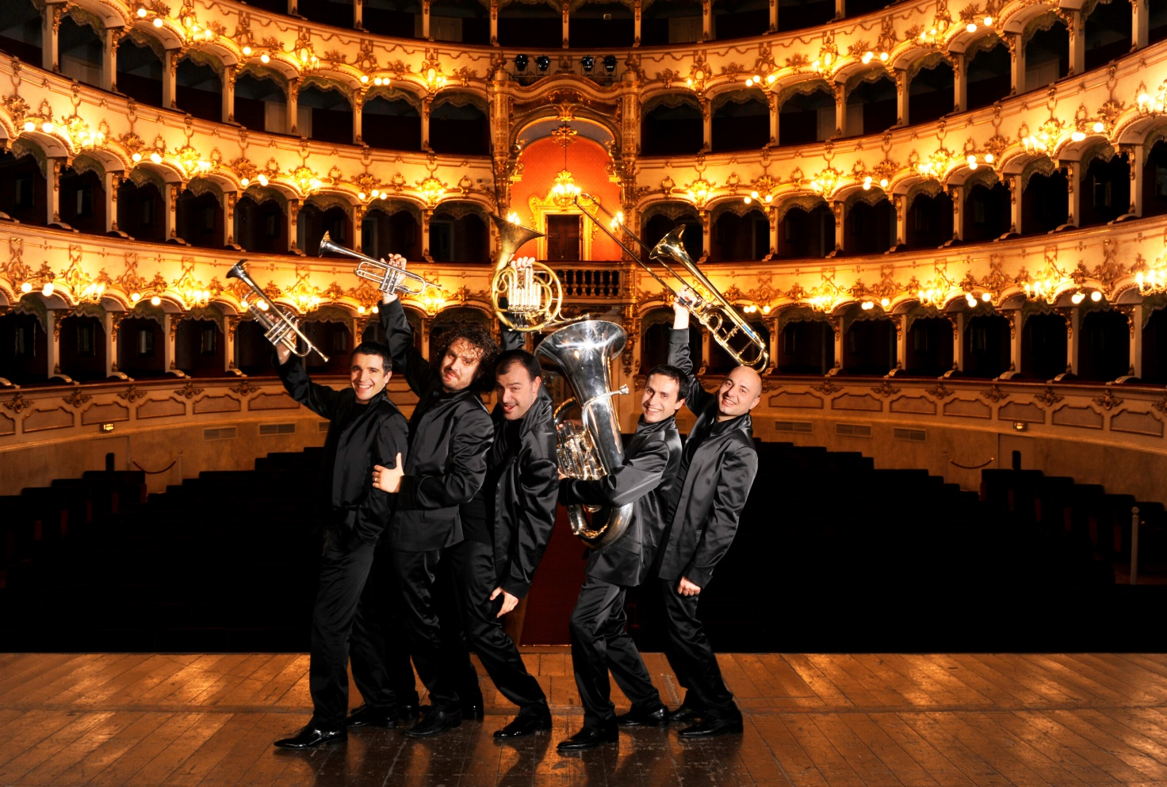
When Marco Braito (trumpet), Marco Pierobon (trumpet), Nilo Caracristi (horn), Gianluca Scipioni (trombone), Stefano Ammannati (tuba) – in 1999, “only” five musicians from the world’s most prestigious orchestras (the Chicago Symphony Orchestra, the Frankfurt Opera, La Scala in Milan, the Santa Cecilia Academy, Teatro Regio in Turin and the RAI National Symphony Orchestra) – founded the GOMALAN BRASS Quintet, they didn’t realise that they were creating one of the most successful and entertaining shows of our time. The quintet’s extraordinary musical and virtuoso qualities, according to Zubin Mehta, a repertoire, based on original or existing arrangements, that ranges from Renaissance to contemporary music and movies soundtracks, the theatrical wit of their annually renewed performances have seduced both the audience and the critics, worldwide.
In November 2001, the group won the first prize at the “Town of Passau” International Brass Competition, one of the world’s most prestigious brass awards, receiving enthusiastic praise from international brass celebrities such as Roger Bobo, David Ohanian, Steven Mead, Dale Clevenger and Froydis Ree Wekre. Many radios have broadcast concerts and pieces by the Gomalan Brass Quintet, to name but a few: Bayerisches Rundfunk, Radio Vaticana, Radio Classica, Radio Canada and Radio Rai Tre (for whom the group has performed several world premieres).
The Quintet has released their first two Cds by Summit Records, and the third one by Naxos is already the most downloaded on classicsonline.com. The fourth one was released to celebrate the first activity decade. (see DISCOGRAPHY).
During 2010 was released a Dvd containing the Lodi concert (Auditorium BNL) and a documentary over the group’s activity.
What they say about them:
“This is a great group: uncommon virtuosity and musical skill.”
(Zubin Metha)
“They will excite every emotion you are capable of in the course of the concert.”
(Vince Di Martino)
“The Gomalan Quintet is the most amazing brass quintet I’ve ever encountered. A concert from this extraordinary group is an unforgettable experience.”
(Roger Bobo)

