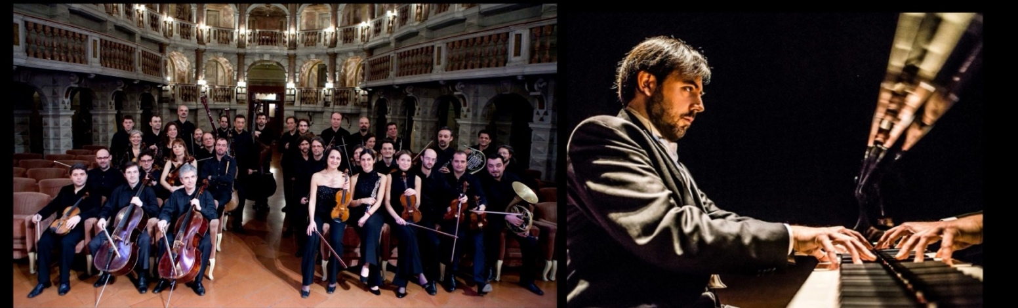
ORCHESTRA DA CAMERA DI MANTOVA was founded in 1981 and has proven to have technical brilliance, great attention to style and a constant search for sound quality. In 1997, Italian musical critics awarded the Orchestra da Camera di Mantova the “Franco Abbiati” prize for its “unique stylistic refinement and constant search for sound quality, which merges Italian instrumental tradition and classical repertoire”. The orchestra performs in Teatro Bibiena in Mantova, which is an authentic jewel of architecture and acoustics. The Orchestra da Camera di Mantova has been performing for over 30 years with world-renowned conductors and soloists; some of these include: Gidon Kremer, Shlomo Mintz, Joshua Bell, Salvatore Accardo, Umberto Benedetti Michelangeli, Giuliano Carmignola, Uto Ughi, Mischa Maisky, Enrico Dindo, Mario Brunello, Miklos Perenyi, Sol Gabetta, Alexander Lonquich, Bruno Canino, Katia and Marielle Labeque, Maria Tipo, Andrea Lucchesini, the unforgettable Astor Piazzola and Severino Gazzelloni to name a few. The OCM has given numerous concerts both in Italy and abroad and has performed in theatres and concert halls all over Europe, the USA, Central and South America and Asia.
In the last ten years, the national and international projects of the orchestra have centred on important artist cycles such as the “Beethoven Project” from 2002-2004 with several famous Italian soloists and Umberto Benedetti Michelangeli as conductor. The “Beethoven Project” centred on the symphonic works of the German composer, while taking on inspiration from more recent historical critiques.
In the 2004/2005 concert season, the Orchestra da Camera di Mantova developed the “W.A. Mozart Project” that was dedicated to Mozart’s piano works. The project debuted in May 2004 at the Parco della Musica in Rome with pianist Alexander Lonquich performing Mozart’s piano pieces.
Between 2004 and 2007, the orchestra carried out a project centred on Mozart’s sacred works and directed by Umberto Benedetti Michelangeli, with concerts in Abbazia di Chiaravalle in Milan and numerous other Italian cities.
For the occasion of the bicentennial of Haydn’s death (1732-1809), the Orchestra da Camera di Mantova developed a 3-year project called, Haydn l’europeo che amava l’Italia. The project allowed for several performances of Haydn’s symphonic, sacred and chamber works.
In 2010, for the bicentennial celebration of Schumann’s birth, the orchestra performed all of the German composer’s symphonies and thus gained support from audiences and critics alike.
The Orchestra da Camera di Mantova has recorded for several television and radio programs such as RAI, Bayerischer Rundfunk and the Swiss RSTI. In September 2009, the ensemble recorded three of Haydn’s symphonies, on commission by the most important Italian musical magazine, “Amadeus”. Most recently, with a recording project dedicated to Mozart’s piano concertos, the orchestra has recorded two well-appreciated CDs together with pianist Angela Hewitt that have been published by Hyperion in 2011.
Since 1993, the Orchestra da Camera di Mantova has held a very successful yearly season, Tempo d’Orchestra, with the contribution of famous Italian and foreign soloists, chamber groups and orchestras from around the world.
MASSIMILIANO FERRATI è Massimiliano Ferrati is one of the most impressive Italian musicians of his generation, renowned for his extraordinary musicality, tecnical strengh and charismatic performances.
Prize winner in international competitions members of the World Federation of International Music Competitions (WFIMC) based in Geneva such as UNISA International Piano Competition in Pretoria (special prize for the "best performance of the Russian piece": Musorgskij's Pictures at an Exhibition), the "Esther Honens International Piano Competition" in Calgary, the "Guardian International Piano Competition" in Dublin, the “F. Busoni” International Piano Competition in Bolzano (where the jury awarded him also the special prize for "the best Ferruccio Busoni interpreter"), the "A. Casagrande" International Piano Competition in Terni (where the jury awarded him also the special prize for "the best Alessandro Casagrande interpreter"), the “Rina Sala Gallo” International Piano Competition" in Monza, the "Arthur Rubinstein" International Piano Master Competition in Tel Aviv.
He has given several recitals both in Italy and abroad, among them: Milan ("G. Verdi" Hall of the Conservatory on the occasion of the celebration of Nikita Magaloff), Padua ("Hall of Giants"), Turin (RAI Auditorium), Paris (Salle Cortot), Venice (Gran Teatro "La Fenice"), Florence (Palazzo Strozzi), Warsaw (State Philharmonia and Lazienki Palace), Hamburg (Musik-Halle), Naples (Teatro delle Palme and Teatro San Carlo), Salzburg (Wiener-Saal), Klagenfurt (Stadttheater), Munich (Kaulbach Villa), Calgary (Jack Singer Concert Hall), Dublin (National Concert Hall), New York (Mannes College of Music and The Kaye Playhouse at Hunter College), Tel Aviv (Mann Auditorium and Tel Aviv Museum), London (Purcell Room), Tbilisi (National Palace – Tbiisi Piano Fest), Recanati (Conero International Music Festival), Leeds (Great Hall of the University), Pretoria (Old Mutual Hall) and Rome (Auditorium of the "S. Cecilia" Academy and Teatro Nazionale).
He has performed as soloist with many prestigious orchestras, such as: Calgary Philharmonic Orchestra, Gli Archi della Scala, Israel Philharmonic Orchestra, Moscow Symphony Orchestra, National Symphony Orchestra of Ireland, Orchestra di Padova e del Veneto, Orchestra "Haydn" di Bolzano e Trento, Orchestra Regionale del Lazio, Roma Sinfonietta, Orchestra da Camera Slesiana of Katowice with conductors like: Mario Brunello, Mendi Rodan, Anton Nanut, Robert Houlihan, Christoph Eberle, Bruno Aprea, Alberto Veronesi, Alexei Kornienko, Jan Wincenti Hawel and played with chamber groups such as: St. Lawrence String Quartet, Aviv String Quartet, Trio Rachmaninoff, Solisti dell'Orchestra d'Archi Italiana, TrioLogìa, Trio Veneto and artists as David Garrett, Sergey Ostrovsky, Fabio Paggioro, Stefano Furini, Danilo Rossi, Alberto Salomon, Luca De Muro, Simone Tieppo, Jacopo Francini, Davide Simoncini, Alessandro Carbonare.
His performances have been recorded and broadcasted by TVP (Telewizja Polska S. A.), CBC Radio & Television Canada, RTÉ (Radio Telefís Éireann), Bayerischer Rundfunk München, Radio Allegro Johannesburg, Israel Radio Voice of Music, BBC Radio, RAI Radio Televisione Italiana, Radio Ljubljana.
In 2018 he has been awarded by the “Premio Quadrivio” reseved to the most distinguished international artists.
He has recorded the CD Mozart Piano Sonatas for Velut Luna, and for Brilliant Classics two monographic works on the italian composers Respighi and Martucci. Two more CD with Prokofiev works will be released in 2018.
Graduated with a first-class honours diploma at the "A.Buzzolla" Conservatory in Adria under the guidance of Mila Zamparo, he studied with very important teachers like the Russian pianist Konstantin Bogino, Paul Badura-Skoda and Sergio Perticaroli (at the Mozarteum in Salzburg and at the "S.Cecilia" Academy in Rome where he received the first-class honours diploma). He partecipated in Masterclasses with Fausto Zadra, Bruno Rigutto, Vladimir Ogarkov, Svetlana Bogino, Trio di Trieste (Dario De Rosa, Renato Zanettovich e Amedeo Baldovino), Piero Rattalino, Dina Joffe, Franco Rossi, Pier Narciso Masi.
He gives Master Classes regularly in Italy and abroad (New York - International Keyboard Institute and Festival, Kiev - Ciaikovskij National Academy, Tokyo - Showa University, Recanati – Conero International Music Festival, Tbilisi – Tbilisi Piano Fest) and takes part in Juries in International Piano Competitions such as "A. Casagrande" - Terni, Sydney, "Luciani" - Cosenza.
He is piano professor at the Conservatory "Agostino Steffani" in Castelfranco Veneto (Italy).
A project by:
DF Artists International Music Management
Vicolo cadrega, 7
37121 VERONA
Desiree Fusi: + 39 392 98 62 385
info@df-artists.com

