BROS QUARTET
saxophones

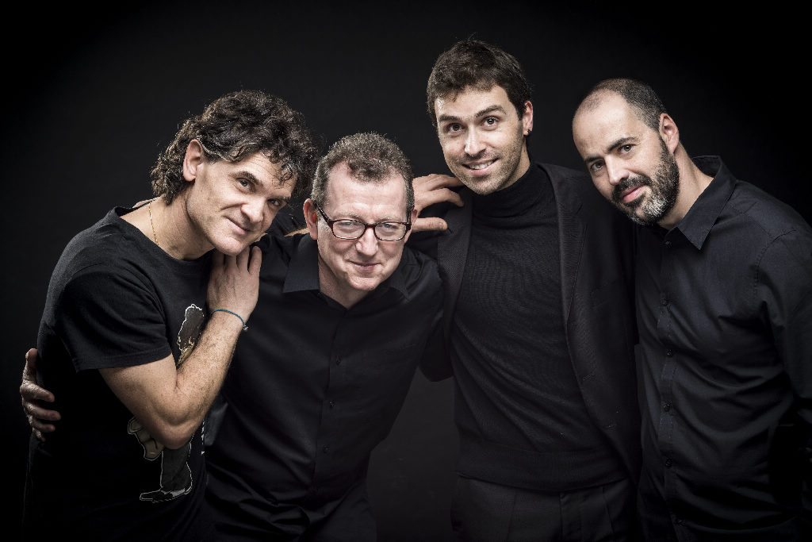

BROS QUARTET: Gerard McChrystal, Antonio Felipe Belijar, João Pedro Silva, Mario Marzi.

Coming from Ireland, Spain, Italy and Portugal, the Bros Saxophone Quartet sprang from the desire of four friends to fuse their different experiences as soloists in the service of chamber music.
As refined interpreters perfectly identified with their saxophones, they set out on a musical journey whose search issues in multifarious musical places and languages.
It is sensitive virtuosismo, and meaning and emotion, which make the B.S.Q one of the most interesting and innovative ensembles on the international scene.
The fusion of their various musical experiences seemed to them to be the ideal mirror in which to seek a meeting point between emotion, instinct and personal search.
Music has helped to strengthen the friendship between these four friends, confirming once more that it is a very special art without borders and walls, because it lives through its own incredible strength and freedom.
After their premiere, at the XVII World Saxophone Congress, Strasbourg, the B.S.Q. recorded a CD for the Italian Label Stradivarius with the piece "Pagine", by Salvatore Sciarrino, highliting the participation on the Logano Music Festival (Switzerland), European Saxophone Congress (Portugal), SIcily Saxophone Academy (Italy) and Milano Music Festival (Italy).
​

QUOTE
“…Of the many hot tickets of the congress, the much-anticipated performance of Bros Quartet had the audience queuing in the corridors. The charismatic foursome of Gerard McChrystal, Antonio Felipe Belijar, Mario Marzi and João Pedro Silva presented a diverse, energetic and hugely entertaining programme, reflecting the musical background of the four players.”
​
in CASS (Clarinet & Sax Society) mag

ABOUT THEM

Gerard McChrystal comes from Derry, N.Ireland. He took up the saxophone as a second study for his RNCM audition in 1982. By 1987 he had made his concerto debut with the RTE Concert Orchestra playing the Dubois concerto live on TV in the final of RTE Musiciaan of the Future. His UK debut was with the Philharmonia in 1989 premiering Out of the Cool by Dave Heath.
He studied at the RNCM, The Guildhall School, London and Northwestern University, Chicago followed. He has worked with Philip Glass, The Smith Quartet, guitarist Craig Ogden, percussionists Ensemble Bash, The Soweto String Quartet, tenorist Tommy Smith, Uilleann piper Liam o Flynn and vocal group Anuna.
Gerard has performed in 35 countries including USA, China, South Africa, Indonesia, Azerbaijan, Korea, Sweden and all over Europe including Italy, France, Spain and Slovenia. He has recorded albums with BBC NOW, Ulster Orchestra, London Musici, guitarist Craig Ogden, The Smith Quartet, Yan Pascal Tortelier and record labels include Chandos, Signum Records and Silva Screen. He has developed a repertoire of accessible new works, often with a celtic influence some of which have been published in his saxophone series by Camden Music, London and Reed Music, Australia.
Orchestras Gerard has worked with include The Philharmonia, BBC Scottish Symphony Orchestra, BBC Concert Orchestra, National Symphony of Ireland, Stuttgart Staatsorchester and the Orchestra of San Francisco Ballet. Venues include San Francisco Opera House, Baku Opera House, Royal Abert Hall, St David’s Hall, Cardiff, National Concert Hall, Dublin and a longhut in Sarawak, Borneo. His album Aria was named as one of the best classical CDs of 2011 by Classic FM and was chosen as one of David Mellor’s Connoiseur’s Choice. It was also RTE Lyric FM’s Album of the week in November 2011.
Gerard was an ambassador for Derry-Londonderry UK City of Culture 2013. His new solo programme InterFuse for saxophone and electronics has won two awards from the Arts Council. In 2014 Gerard premiered a new work for sax and loop station in Ireland. The new work, Mid-term Break was commissioned from Gerard in memory of the poet Seamus Heaney. He has been invited to be on the jury of jury of many international competitions including The Royal Overseas League Competition, London and The 5th Adolphe Sax International Saxophone Competition, which was held in Dinant in 2010. In 2015-16 season he will perform in Milan, Paris, Vienna, Lisbon and London.

Antonio Felipe Belijar (Madrid 1978) began his musical studies at the Conservatorio Superior de Música de Madrid aged seven, graduating with the Honour Prize in Saxophone.
He was awarded several prizes: First Prize at the 2nd International Competition for Young Soloists category B- (under 19 years old), held in Alicante in 1995. First Prize and Special Prize at the 3rd International Competition for Young Soloists (up to the age of 25) in 1996. Second Prize at the 4th International Competition Villa de San Juan (age limit 30 years) moreover, obtaining Special Prize (for best saxophonist below 20). First Prize at the 1st Saxophone CompetitionVilla de Benidorm held in 1999. First Prize at the 14th Music Competition Pacem in Terris (2001), in Bayreuth, Germany. Third Prize and Prix de la Province de Liegè at the 3rd International Competition Adolphe Sax(2002), held in Dinant (Belgium). Second Prize at the 4th International Competition Adolphe Sax (2006), in Dinant (Belgium). First Prize at the 1st Yamaha International Competition for Saxophone Quartet with Octavia saxophone quartet. Second Prize at Pedro Bote Chamber Music Competition (2009) with Octavia saxophone quartet. First Prize at 9th Mirabent I Magrans chamber music competition (2011) with Octavia saxophone quartet. He attended courses given by Claude Delangle, Jean-Marie Londeix, Nobuya Sugawa, Arno Bornkamp, Vincent David, Jean-Denis Michat and Serge Bichon. He has played solo concerts with orchestra in Spain, Germany, Portugal and Belgium. He has performed with orchestras Radio Televisión Española (ORTVE), Orquesta de Cámara Andrés Segovia, Comunidad de Madrid and Schleswig- Holstein Musik Festival Orchester. Conductors he has worked with include David Shallon, Esa-Pekka Saloen, Donald Runnicles and Christoph Eschenbach. In 2005 he collaborated with Karlheinz Stockhausen for the recording of Knabenduett, together with Julien Petit.(cd n. 78 ed. Stockhausen).
Selmer Paris chose him for the 1er Tremplin Jeunes 2002-2003. He regularly gives masterclasses in Spain, Portugal and Italy. Antonio is very interested in violin repertoire and transcribes many of the important works. His transcriptions are always caracterized by a faithfulness to the original, even when the performance requires confidence with the altissimo register. He is member of Octavia Saxophone Quartet, Bros. Quartet and musical director of Sax Antiqua, a group of saxophones specialising in early music repertoire.
He teaches at Conservatorio Superior de Música de Castilla-La Mancha.

João Pedro Silva obtained a Master in music performance (saxophone) and music pedagogy (saxophone) by the Lisbon Superior Music School. Born in Palmela, Portugal, began his musical studies at the Humanitaria Philharmonic Society, Palmela, with Silvério Camolas. Studied with José Massarrão at Lisbon Superior Music School, with Alberto Roque at Almada Professional Music School with and Pedro Moreira at Luis Villas-Boas Jazz School. He also attended masterclass and seminars with Daniel Deffayet, James Houlik, Jean-Marie Londeix, Claude Delangle, Jean-Yves Formeau, Henk Van Twillert, Vincent David, Carlos Martins, Jerry Bergonzi, among others. He was laureate on Portuguese and international saxophone competitions.
As a soloist, has performed with the Portuguese Symphonic Band, Lisbon Sinfonietta Orchestra, Portuguese Navy Band, Portuguese Republican Guard Chamber Orchestra, Lisbon Metropolitana Wind Orchestra, Portuguese Double Reed Ensemble and the Lisbon Metropolitana Percussion Orchestra.
He has performed with some of the most important Portuguese orchestras, like Portuguese Symphonic Orchestra, Lisbon Metropolitan Orchestra, Lisbon Soloists Orchestra, Lisbon Sinfonietta Orchestra, Lisbon Hot Club Big Band, working with conducters like Eric Stearn, Alain Guingal, Wayne Marshall, among others.
He has represented Portugal on the XIV World Saxophone Congress, Lubiana, Sloven, and at the XVII World Saxophone Congress, Strasbourg, France, playing with Artemsax Quartet, BROS Quartet, fusion OUT and Metropolitana Saxophone Ensemble. In the XVII he was also invited to present a lecture about new music pedagogical approaches to the saxophone learning.
He is the tenor saxophone of the international quartet, BROS quartet, had recording the CD “Pagine” by Salvatore Sciarrino, with the Italian label Stradivarius.
He has making a linking work with several Portuguese composers, on the creation on new repertoire for saxophone. He works regularly in artistic collaboration with several composers, in the creation of new repertoire for saxophone. It has established a continuous partnership with Antena 2 (Portuguese Classic Radio) on the news projects.
As a soloist has recorded the cds: “TIBI - ”New Portuguese and American Music for saxophone, and more…”, “João Pedro Silva plays Jorge Salgueiro Vol.1” and “João Pedro Silva plays Jorge Salgueiro Vol.2”. With Lino Guerreiro, is the author of the first Portuguese didactic book for the saxophone learning, “The Educational Saxophone”, with preface by Claude Delangle, edited by AVA Musical Editions.
He is member of the international saxophone quartet Bros. Quartet, Artemsax Quartet, L.U.M.E. - Lisbon Underground Music Ensemble and Fusion Out (music for saxophone, accordion, electronic and video), with which all it has presented all over Portugal and abroad and edited several CDs.
He is the musical and artistic director of the Metropolitana Saxophone Ensemble, with who has recorded and edited a cd with new original Portuguese music for saxophone ensemble.
João is founding member and Vice-President of the Portuguese Saxophone Association. He takes part of the EURSAX 17 European Saxophone Congress boarding team.
He is saxophone and chamber music professor at the Lisbon Metropolitana Professional Music School and Palmela Regional Conservatory of Palmela. He is normally invited to give masterclass and workshops.
He is the artistic director of FISP - Palmela International Saxophone Festival.
He is Yamaha and D’Addario Woodwinds artist.

Mario Marzi is a winner of nine national and four international competitions. He has performed with prestigious orchestras including The Orchestra Sinfonica RAI di Torino, Accademia naz. di Santa Cecilia, Arena di Verona, Teatro Comunale di Firenze, Teatro alla Fenice di Venezia, Orchestra della Svizzera Italiana and the Caracas Symphony Orchestra.
Mario has worked for twenty years with Teatro alla Scala and with the Filarmonica della Scala under the baton of some of today's leading conductors including R. Muti, C. M. Giulini, G. Prètre, L. Maazel, L. Berio, S. Bychkov, G. Sinopoli, W. Sawallisch, M. W. Chung, G. Dudamel, C. Abbado, R. Chailly and D. Harding.
He often plays with Riccardo Muti and is regularly invited to join Zubin Mehta and the Orchestra del Maggio Musicale Fiorentino on concert tours. He has played at famous national and international festivals such as the Biennale di Venezia, Settembre Musica, La Scala di Milano, Accademia Filarmonica di Roma and the Ravenna Festival. He has also performed in Salzburg, Athens, Madrid, Saint Petersburg and Mexico City. Important venues include Carnegie Hall, New York, The Suntory Hall, Tokyo, The Gewandhaus, Leipzig, The Musikverein, Vienna, The Schauspielhaus, Berlin, The Lacma Museum, Los Angeles, The Grand National Theatre of China, Beijing, The European Parliament, Brussels, The Ciajkovskij Hall, Moscow and The Liceu, Barcelona.
He devoted himself to 20th century repertoire and some of the most important contemporary works for saxophone are dedicated to him. He has recorded for EMI, Edipan, Stradivarius, Agorà, BMG and Sony Classical. His CD of the major saxophone concertos for soloist and orchestra, which he recorded with G. Verdi Symphony Orchestra conducted by H. Schellemberger, was recently released in Italy by Amadeus and is now internationally released on ARTS (München). He is a Rico endorsee.
Mario Marzi teaches saxophone at G. Verdi Conservatory in Milan, gives postgraduate courses and master classes in Oporto, Amsterdam, Lisboa, Frankfurt, Beijing, Wien, London, Washington, Sydney, Denver and Caracas, within the Abreu’s project (El Sistema).
He has been on the jury of many international competitions including The 5th Adolphe Sax International Saxophone Competition, which was held in Dinant in 2010. He is the Italian representative for Gerry Mulligan’s Publisher. Mario also is editor of several educational scores for Carisch.
His book Il Saxofono Zecchini Ed. was published in October 2009.

