ALESSIO ALLEGRINI
meets
TETRAKTIS
PERCUSSIONI

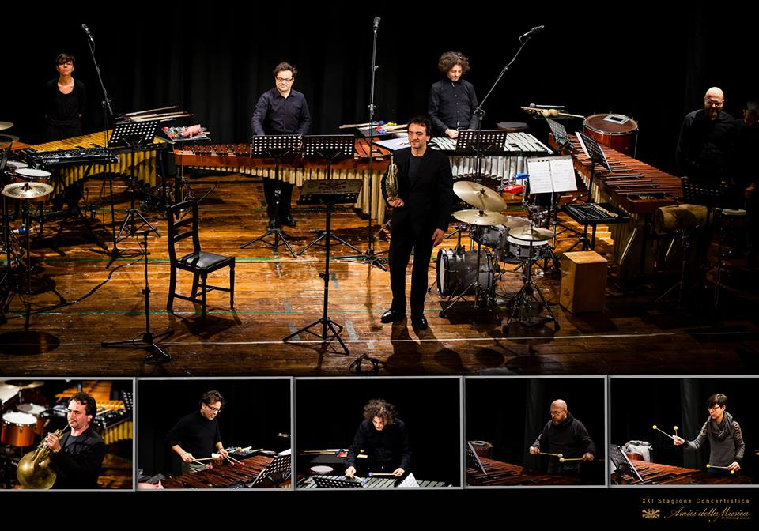

PROGRAMME
Lenght: 1 hour and 10 minutes approx.

Luigi Cherubini “Sonata n. 2 in F Major, per horn and strings”
Arr. for horn and percussion quartet

Nebojsa Jovan Zivkovic “Trio per Uno” – for percussion trio

Ramberto Ciammarughi “Elegia” (dedicated to Alessio Allegrini e Tetraktis)

Gioacchino Rossini “L'italiana in Algeri” arr. for percussion quartet with
“La Caccia” for horn solo

Interval

Riccardo Panfili “OUT” (dedicated to Alessio Allegrini e Tetraktis)

John Cage “Third Construction” for percussion quartet

A.A.V.V. “Brasilian Suite” elab. by David Short on brazilian folk melodies
(dedicated to Alessio Allegrini e Tetraktis).

French horn soloist: Alessio Allegrini
Tetraktis Percussion Ensemble: Gianluca Saveri
Laura Mancini
Gianni Maestrucci
Leonardo Ramadori

French horn virtuoso Alessio Allegrini is one of Europe’s most sought-after solo and orchestral performers. At 23 years old Alessio won the position of horn soloist at Teatro alla Scala under the direction of Riccardo Muti, and he served it from 1995- 2002. A prize winner of both the Munich Horn and Prague Spring competitions, he made his debut as solo horn with the Berliner Philharmoniker under the baton of Claudio Abbado in 2000. Esteemed for his solo horn performances of the symphonic repertoire, Alessio has worked with many of the world’s pre-eminent conductors, including Carlo Maria Giulini, Pierre Boulez, Daniel Barenboim, Wolfgang Sawallisch, Lorin Maazel, Myung-Whun Chung, Mariss Jansons, Valery Gergiev and Simon Rattle.
Alessio has performed Britten’s Serenade for Tenor, Horn, and strings with Ian Bostridge, Brahm’s Horn Trio with Salvatore Accardo, and the Mozart horn concertos with Orchestra Mozart and Claudio Abbado. His past performances have included appearances with the Bayerischer Rundfunk Orchester, and the orchestras of Teatro alla Scala, La Fenice, Santa Cecilia in Rome, in addition to first horn engagements with the Lucerne Festival Orchestra, the Chamber Orchestra of Europe and Mahler Chamber Orchestra.
Alessio’s discography includes La Grande Fanfare: an album of chamber music with I Solisti della Scala Milano (Tudor Records), DVD recordings of Mahler Symphonies 3, 6, and 7 with the Lucerne Festival Orchestra under the baton of Claudio Abbado.
He appeared in the documentary L’altra voce della Musica following the travel of Claudio Abbado between Havana and Caracas, as well as in the movie Rhythm Is It, featuring the Berliner Philharmoniker and Simon Rattle. His collaboration with Orchestra Mozart and Abbado has culminated in the live recording of the complete Mozart Horn concertos for Deutsche Grammophon, as well as a DVD of Bach’s second Brandenburg concerto.
He is the Founder and Music Director of the Human Rights Orchestra. The mission of this group is to foster a culture of humanism through music, in support of the Universal Declaration of Human Rights. It includes players of major symphony orchestras worldwide and past concerts saw performances at the Festival Sull’Acqua in Colico, at Abbazia of Farfa, in Rome and Fermo.
In May 2010 the HRO conducted by Allegrini has performed with pianist Maria Joao Pires for the 7th International Forum for Human Rights in Lucerne.
He made also his debut at Teatro Lirico in Cagliari conducted a symphonic concert with Wagner and Brahms compositions. Alessio has conducted also many concerts in Yamanouchi, Toyonaka, Nabari and at Osaka’s Symphony Hall.

Since their coming together in 1993 Tetraktis has been acknowledged as one of the most brilliant, innovative and forward-looking Italian percussion ensemble by critics and audiences of all different ages and backgrounds. Innovation and diversity of programs, insatiable curiosity, virtuosity, infectious passion and fun, and a substantial history of collaborations and commissions are their distinctive hallmarks.
Tetraktis’ commitment to new music have brought a breath of fresh air to Italian musical life.They have made a substantial contribution to the repertoire for percussion ensemble by commissioning and championing new works by composers such as Giovanni Sollima, Carlo Boccadoro, Paolo Ugoletti, Thomas Briccetti, Tonino Battista, Carlo Crivelli, Alessandro Annunziata, Davide Zannoni, Riccardo Panfili. Tetraktis' collaborations spans the whole spectrum of today’s music - from Jazz to Pop and Rock, from Dance to Opera. They have featured as guest ensemble or have hosted in their programs artists such as Alessandro Carbonare, Alessio Allegrini, David Brutti, Stefano “Cocco” Cantini, Roberto Laneri, Micrologus Ensemble, Ramberto Ciammarughi, DJ Ralf, Lorenzo Jovanotti, the video-artist Philipp Geist, as well as dance/theatre companies and directors: Moto Armonico, ATMO, Bruno De Franceschi, Maurizio Smith, Kataklò among many others. Those cooperations resulted in several recordings such as: Millennium Bug (Rara 1999), Drama (self produced 2008), Liaisons Dangereuses (Giotto Music 2007), Piazzarama (Giotto Music 2009), Invenzioni (Decca 2013). In 2017 theyl present a new CD “IONISATION” (Brilliant Classics) with music by Varèse, Chavez, Cowell, Reich, Harrison and Cage.
In music education Tetraktis is involved as the only Italian percussion ensemble able to propose workshops for schools, family concerts and concert clinics for audience of different ages. Their highly successful educational programs are requested by important Italian and European associations every year.
Having given more than 500 concerts Tetraktis toured the U.S.A. twice and have brought their infectious playing to major concert seasons and festivals in Germany, Turkey, Nigeria, Sweden as well as all over Italy: Lingotto Musica (Turin), Amici della Musica di Firenze (Florence), Amici della Musica di Perugia, Amici della Musica di Siracusa e Trapani, Amici della Musica di Torino, Società dei Concerti di Trieste, Unione Musicale di Torino, “Musica Insieme” Bologna, Filarmonica Laudamo di Messina, Famiglia Musicale Reggiana (Reggio Emilia), Filarmonica Umbra, Gioventù Musicale d'Italia di Modena, Bergamo, Biella, Chiavari, Festival dei due Mondi (Spoleto), Aosta Classica, Salone della Musica di Torino, Estate Musicale a Portogruaro, Incontri Musicali della Galleria Nazionale d'Arte Moderna (Roma), Goethe Institut Roma, Ferrara Musica, Società del Quartetto Milano, Filarmonica Romana, Ravello Festival, Stresa Festival, Scarlatti Napoli, Amiata Piano Festival, Teatro di Sondrio, Associazione Musicale Lucchese, Lucca Musica, Istituzione Universitaria dei Concerti di Roma, Teatro di Pisa, Tetaro Sperimentale di Ancona.
The Ensemble is regularly involved in live performances in radio broadcast by Radio Rai Tre. In 2017 they played broadcasted by Radio3 at the Quirinale Palace (residence of the Italian President of the Republic).
The 4 members of the ensemble are virtuosos alone and bring their individual character and experience to the distinct whole of Tetraktis. They have regularly featured as orchestral percussionists in orchestras such as La Scala (Milan), RAI National Orchestra (Rome), Teatro Regio (Turin) – Teatro San Carlo (Naples) Teatro Comunale (Florence), Accademia di Santa Cecilia (Rome), Teatro dell’Opera (Rome), Mahler Chamber Orchestra, Luzern Festival Orchestra, under the batons of conductors such as C. Abbado, R. Muti, G. Sinopoli, L. Maazel, D.Harding, G. Prêtre, D.Oren, M. Rostropovic, G. Kuhn, P. Boulez, A. Pappano, Y. Temirkanov.

Tetraktis percussions: Gianluca Saveri, Laura Mancini, Gianni Maestrucci, Leonardo Ramadori.

